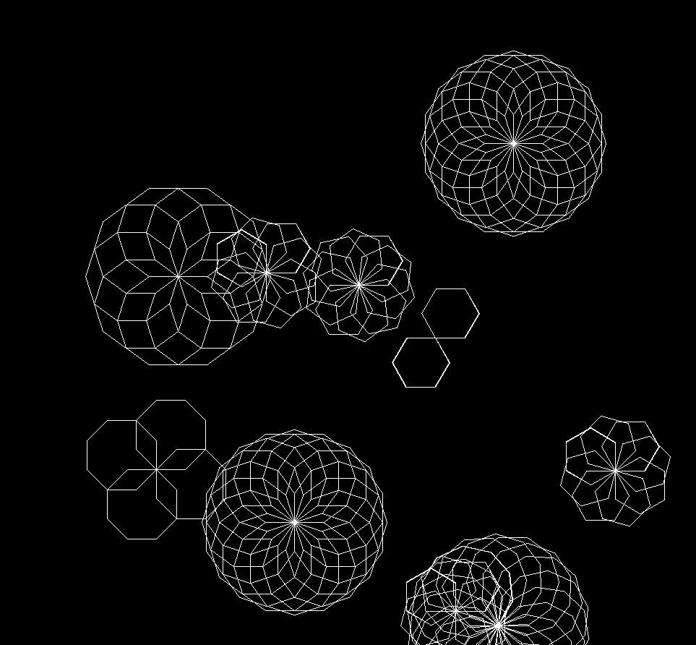import javax.swing.*;  
import java.awt.*;  
import java.util.Random;  
  
public class Snowflake extends Rectangle{  
  
 private static final int *TEN* = 1;  
 private static final int *EIGHT* = 2;  
 private static final int *SIX* = 3;  
  
 private static int *fps* = 40;  
  
 private static int *numOfFlakes* = 0;  
  
 static Random *gen* = new Random();  
  
 static Snowflake[] *flakes* = new Snowflake[10];  
  
 private int numOfShapes = 0;  
 private double angle = 0.0;  
 private int deltaX;  
 private int deltaY;  
  
 public Snowflake(int x, int y, int ang, int type){  
 super(x,y,300,300);  
 this.setBackground(new Color(1,1,1,1));  
 while(numOfShapes<ang*2+4) {  
 Polygon flake;  
 switch (type) {  
 case *TEN*:  
 flake = new Polygon(super.getWidth() / 2, super.getHeight() / 2, 40, 10, angle, Color.*decode*("#ffffff"));  
 this.add(flake, 0);  
 break;  
 case *EIGHT*:  
 flake = new Polygon(super.getWidth() / 2, super.getHeight() / 2, 40, 8, angle, Color.*decode*("#ffffff"));  
 this.add(flake, 0);  
 break;  
 case *SIX*:  
 flake = new Polygon(super.getWidth() / 2, super.getHeight() / 2, 40, 6, angle, Color.*decode*("#ffffff"));  
 this.add(flake, 0);  
 break;  
 }  
  
 numOfShapes++;  
  
 angle = (angle + Math.*PI* / ang);  
 }  
 deltaX = *gen*.nextInt(10)+1;  
 deltaY = *gen*.nextInt(10)+1;  
 }  
  
 public static void main(String[] args) {  
  
 JFrame win = new JFrame("Snow!!!!");  
 win.setBounds(100,100,1000,1000);  
 win.setDefaultCloseOperation(win.*EXIT_ON_CLOSE*);  
 win.setLayout(null);  
 win.setVisible(true);  
 win.getContentPane().setBackground(Color.*decode*("#000000"));  
 int choice;  
  
 for(int i = 0; i<*flakes*.length; i++){  
 choice = *gen*.nextInt(3)+1;  
 switch (choice){  
 case 1:  
 *flakes*[i]=(*tenSidedFlake*(*gen*.nextInt(800)+1,*gen*.nextInt(800)+1, *TEN*));  
 break;  
 case 2:  
 *flakes*[i]=(*eightSidedFlake*(*gen*.nextInt(800)+1,*gen*.nextInt(800)+1,*EIGHT*));  
 break;  
 case 3:  
 *flakes*[i]=(*sixSidedFlake*(*gen*.nextInt(800)+1,*gen*.nextInt(800)+1, *SIX*));  
 break;  
 }  
 win.add(*flakes*[i]);  
 }  
 win.repaint();  
 }  
 public static Snowflake eightSidedFlake(int x, int y, int type){  
 Snowflake s1 = new Snowflake(x,y,*gen*.nextInt(8)+1, type);  
 return s1;  
 }  
 public static Snowflake sixSidedFlake(int x, int y, int type){  
 Snowflake s1 = new Snowflake(x,y,*gen*.nextInt(6)+1, type);  
 return s1;  
 }  
 public static Snowflake tenSidedFlake(int x, int y, int type){  
 Snowflake s1 = new Snowflake(x,y,*gen*.nextInt(12), type);  
 return s1;  
 }  
  
}